37.54: a) Note that the initial velocity is parallel to the x-axis. Thus, according to Eqn. 37.30,
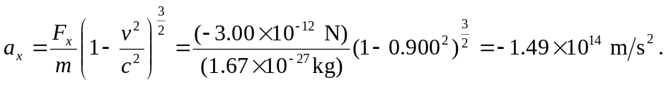
Now note that the initial velocity is perpendicular to the y-axis. Thus, according to Eqn. 37.33,
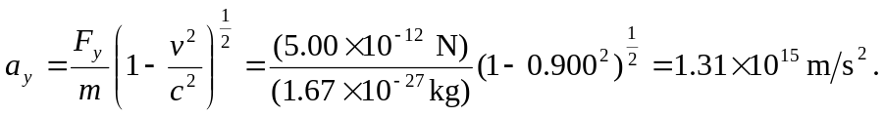
b) The angle between the force and acceleration is given by
